Downloads for Small Area Estimates

Software

R
- Go to: https://posit.co/download/rstudio-desktop/
- Click on “Download and install R”
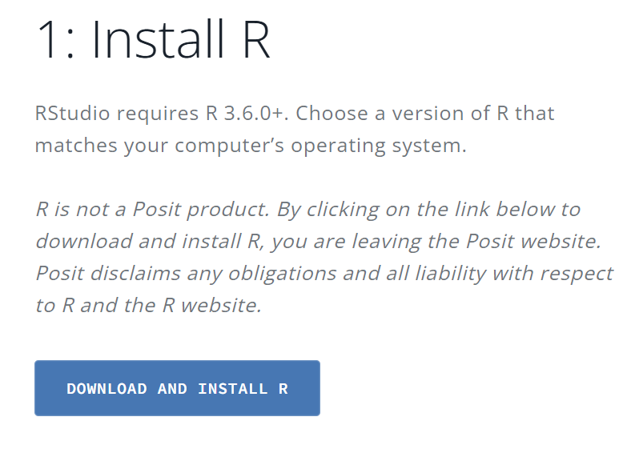
- You will be directed to: https://cran.rstudio.com/
  - If using a Windows Computer, click “Download R for Windows
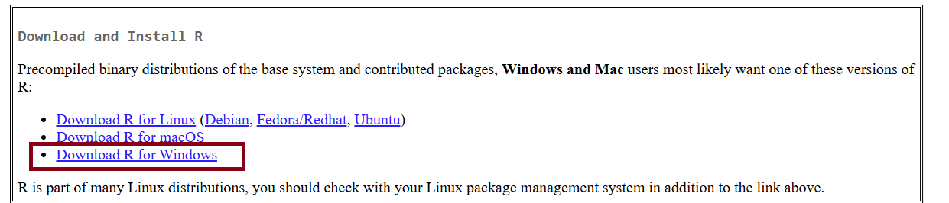
    - Click on “install R for the first time”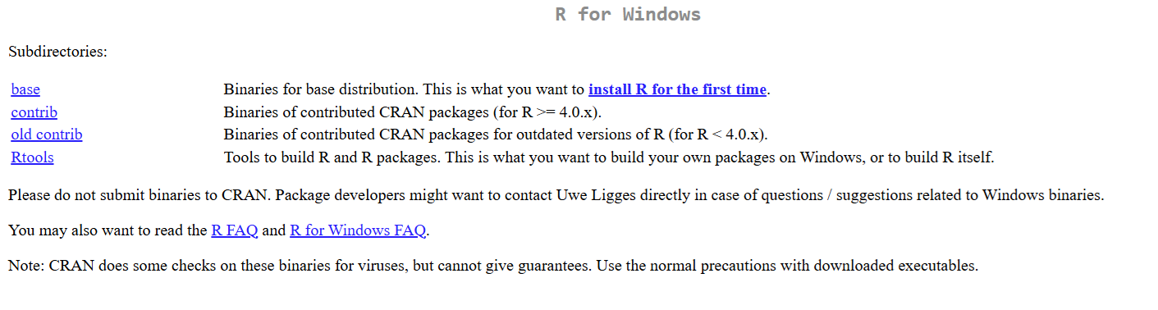
    - Click on “Download R-4.5.2 for Windows” 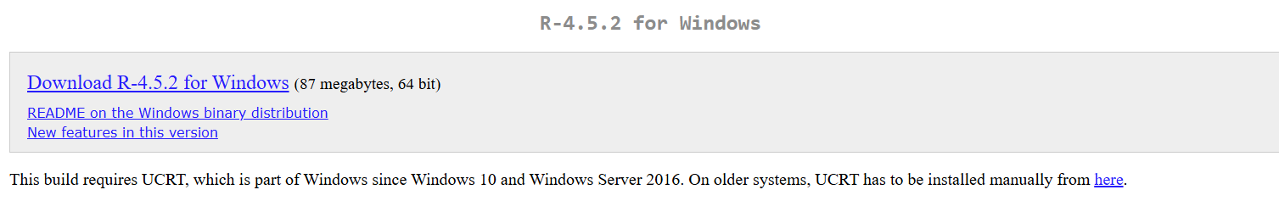
    - This will open your file directory to save the application- save and install R
  - If using a Mac, click “Download R for macOS” 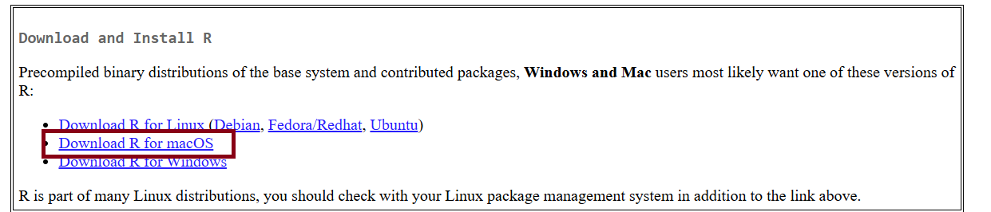
    - Click on “R-4.5.2-arm64.pkg”
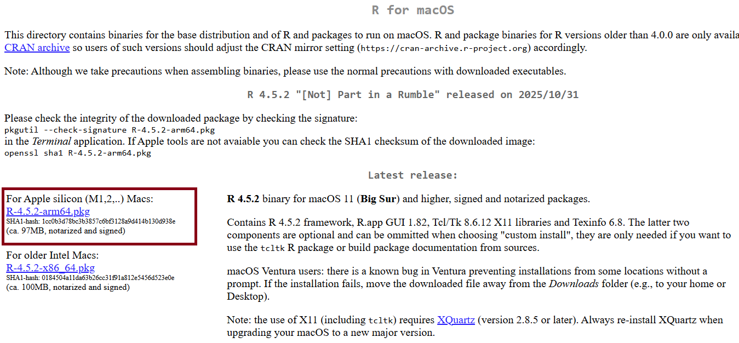
    - This will open your file directory to save the application- save and install R

RStudio
- Go to: https://posit.co/download/rstudio-desktop/
- Click on “Install RStudio” 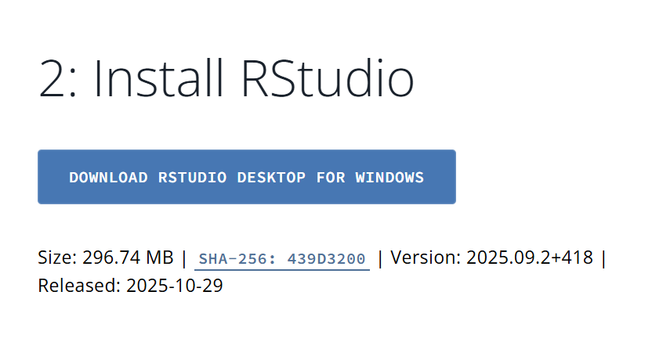
- This will your file directory to save the application- save and install RStudio
- Next, we want to install packages in RStudio. Packages are user written programs that can do special functions. In RStudio:
  - On the bottom right corner, click “Packages” then “Install”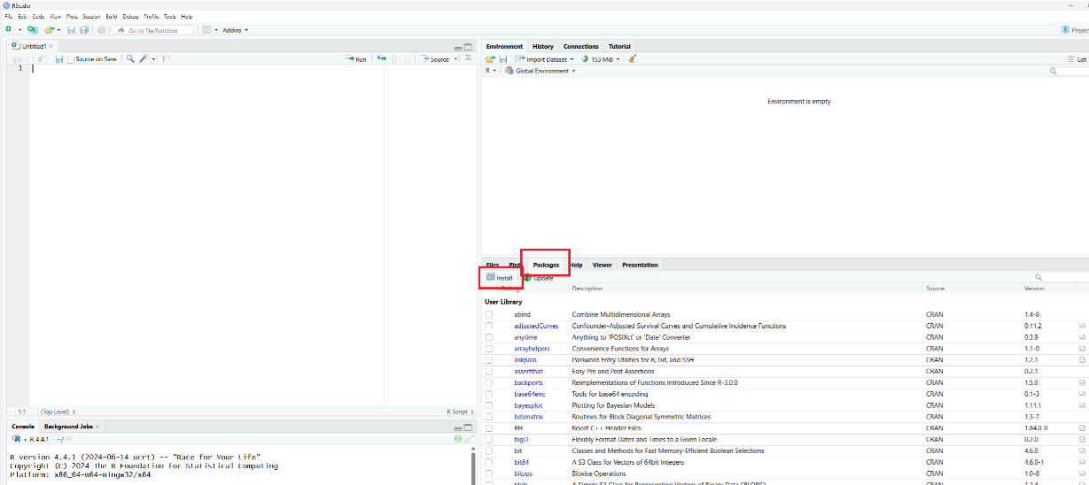
  - A pop up will appear. Search for the package and click install. 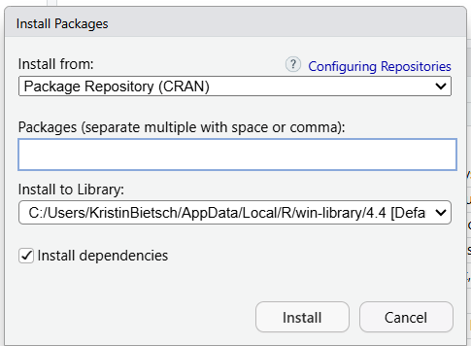
  - The packages needed are: prevR, foreign, tidyverse, sf, haven, sjlabelled, starts

QGIS
- Go to: https://qgis.org/download/
- Click “Skip it and go to download” 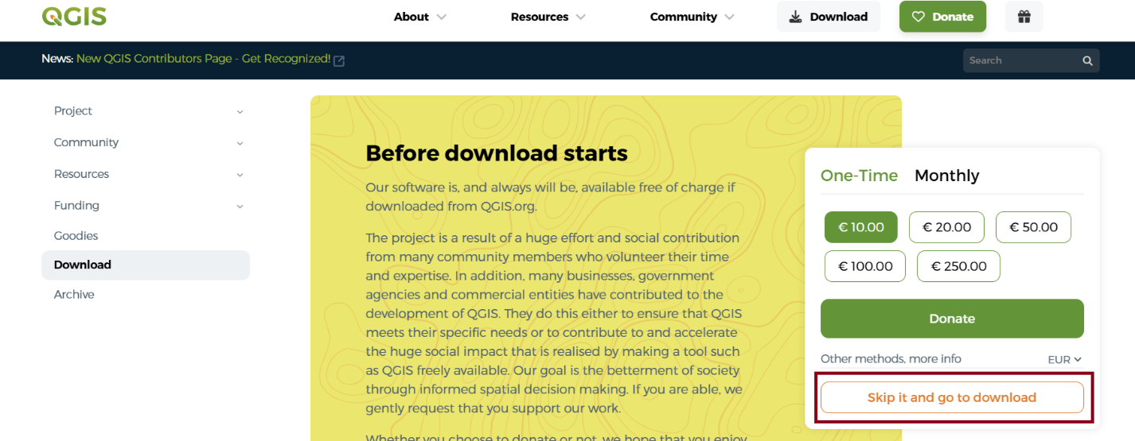
- Click on “OSGeo4W Network Installer” 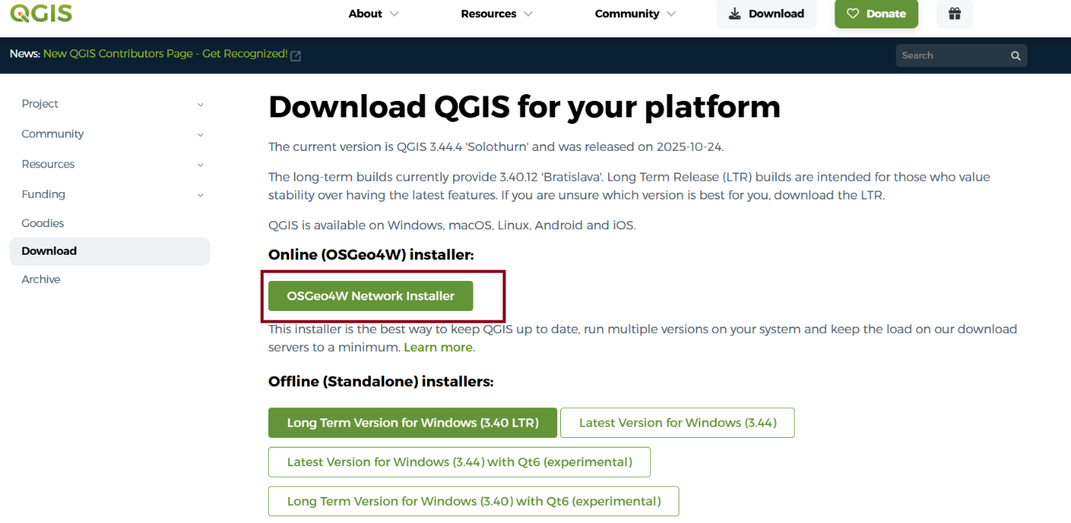
- This will your file directory to save the application- save and install QGIS

Data

Survey Data
We will use DHS data for this analysis- we need Women’s recode and GIS data. Follow these steps to download data ahead of the workshop. It can take up to 2 business days for your data request to be processed, so make sure to request early!

To Register with the DHS:
- Go to https://dhsprogram.com/Data/
  - On the right hand side, under “Download Datasets”, click “Login”
- Under “New Users Registration” click “Register for Dataset Access”
  - Enter information on the New User Registration Form and click “Save and Continue”
  - Enter information on Step 2: Create New Project
    - You do not need to enter in co-researchers’ information
  - In Step 3, choose the region of your country of interest, for example “Sub-Saharan Africa”
    - Click on “Show GPS datasets” (in blue above “Country”)
      - A prompt will ask if you require access to GPS data, select “Yes”
    - Click on the “Survey” and “GPS” columns for the country of interest- you can request multiple countries at a time.
    - Click “Save Selections”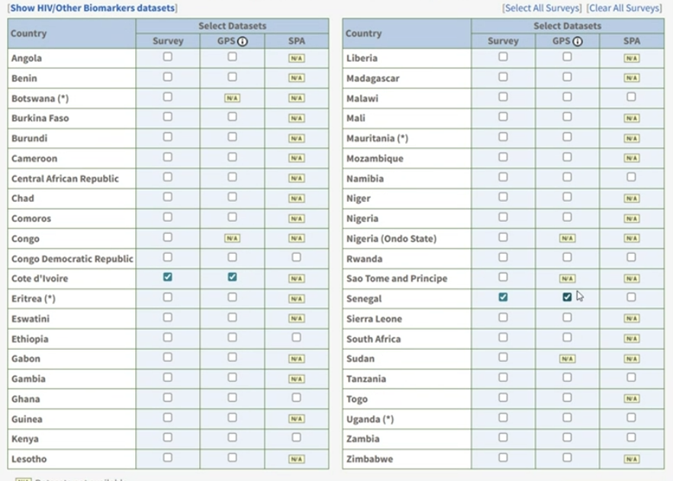
  - When your countries are listed in Step 3, there will be a section called “Requirements of Use”- click on the box that says “Please read and accept the Conditions of Use for The DHS Program datasets
    - You will need to reenter your password to accept the condition of use
  - You will be required to enter the justification for why you need access to GPS data. Enter in the box that you are using GPS data to construct small area estimates for subnational administrative areas.
  - Then click- Submit Dataset Request Now

If you already have a DHS account, but want to request a new country:
- Go to https://dhsprogram.com/Data/
  - On the right-hand side, under “Download Datasets”, click “Login”
- In “My Dataset Account” click “Create a New Project”
  - Follow the steps to create a new project and request your country of interest
To download DHS Data:
- Go to https://dhsprogram.com/Data/
  - On the right-hand side, under “Download Datasets”, click “Login”
- Choose your project from the dropdown menu
- Go to “Download by Single Survey” and choose the country you want to download data for
- Look for the row with the survey year you want to use, and click on “Download” under the column header “Survey Datasets”
- Go to the section that says, “Individual Recode” and click the second box- the file format should say “Stata dataset”
- Go to the bottom of the page under the section labeled “Geographic Data” and click the box next to the data name. The file format should say “Shape file (.shp)”
- Once you download the file, unzip
- Repeat for any other survey you want to use

WorldPop Data
We need small area estimates of population to create our denominators.
To download WorldPop data:
- Go to https://hub.worldpop.org/geodata/listing?id=139
- Search for your country in the search box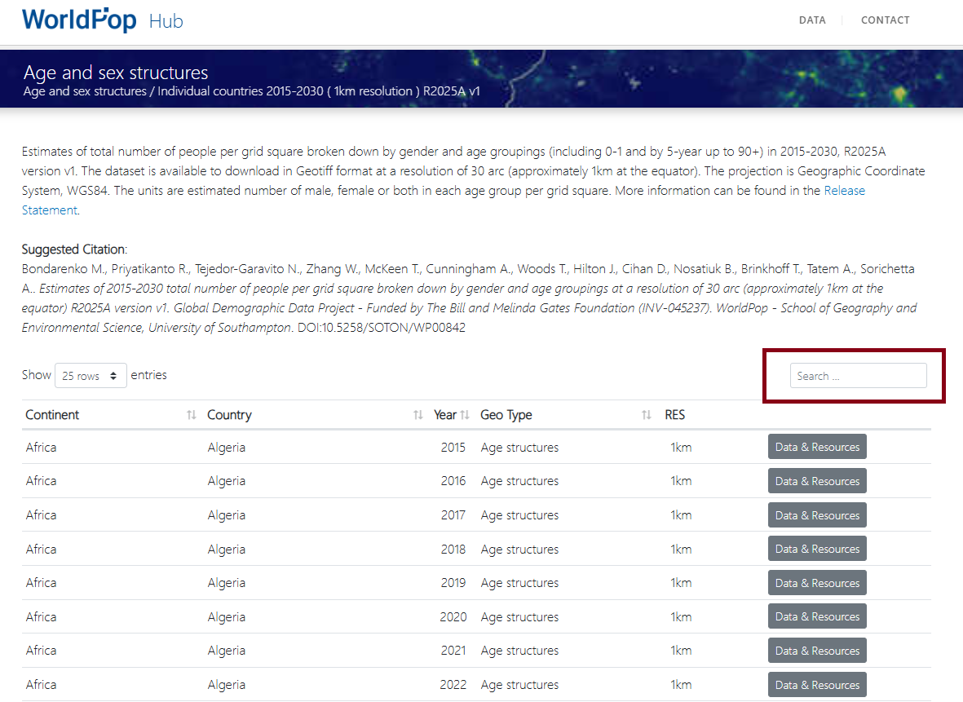
- Find the year that matches your survey and click “Data & Resources”
- The files are available by sex and 5 year age groups
  - You need to download female 15, 20, 25, 30, 35, 40, 45
  - The format is Country_Sex_Age_Year_CN_1km_R2025A_UA_v1.tiff
  - Click on each of the 7 files you need and save them in your folder for this project

Administrative Boundaries
Administrative boundaries can come from many sources. Most governments have official administrative boundary Shape files. Sometimes these files are available in DHIS2.
Alternatively, some shape files (though they may be out of date) are available online from websites such as https://data.humdata.org/
For Senegal, shape files for administrative levels 1-3 are available here: https://data.humdata.org/dataset/cod-ab-sen
- “sen_admbnd_anat_20240520_AB_SHP.zipSHP”
For Cote d’Ivoire, shape files for administrative levels 1-3 are available here: https://data.humdata.org/dataset/cod-ab-civ
- “civ_admbndl_admALL_cntig_ocha_itos_20180706.zipSHP”

